Social Media Marketing Intensive

Set-Up & Optimize These Best Online FREE Marketing Sites for Your Business

Pro Houzz & Business Pinterest

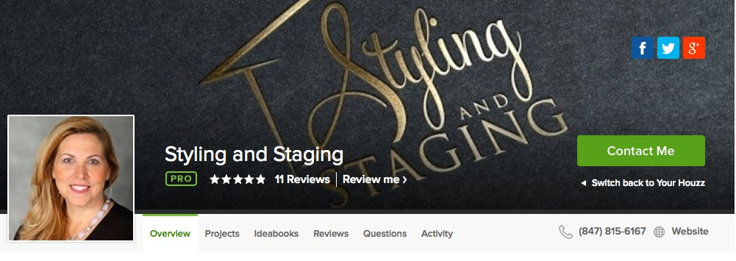

- Want to gain good clients who are ready to make a change in their homes?
- Can homeowners find you, see your work, and read reviews by your previous clients?
- Would you like the opportunity to get Pro Houzz and Business Pinterest set-up and running your business?
- Would you like a FREE business website from Houzz? Check out www.KristinePorter.com for a sample.

In this three hour Hand-On class, you will set-up your Pro Houzz account, and Business.Pinterest. You will learn best practices for easily keeping these accounts current. Your clients will be able to:
- See examples of your work
- Collaborate with ideas
- Write testimonials for others to review
- See your Houzz Awards and Affiliations
- Stay connect with on-trend styles
- Seating limited in this class for hands-on help

For just $99 in this 3 hour intensive, you can set-up these two FREE sites for your business. Bring your own computer. Free 24/7 marketing!

